PF Theory Assignment No. 2

Program 1: Electricity Bill Management System for LESCO
#include <iostream>
#include <iomanip>
using namespace std;

// ---------------- CUSTOMER DATA ----------------
string name, id, type;
int meters;
int units;

// Slab rates (1D array)
double rates[] = {12.21, 14.53, 31.51, 38.41, 41.62, 43.04, 44.18, 49.10};

// ---------------- REGISTER CUSTOMER ----------------
void registerCustomer() {
cout << "Enter Customer Name: ";
cin.ignore();
getline(cin, name);

cout << "Enter Customer ID: ";
cin >> id;

cout << "Customer Type (Household/Commercial): ";
cin >> type;

cout << "Number of meters (1/2): ";
cin >> meters;
}

// ---------------- ELECTRICITY CHARGES ----------------
double consumptionCharges(int u) {
double total = 0;

if (u <= 100) total = u * rates[0];
else if (u <= 200) total = u * rates[1];
else if (u <= 300) total = u * rates[2];
else if (u <= 400) total = u * rates[3];
else if (u <= 500) total = u * rates[4];
else if (u <= 600) total = u * rates[5];
else if (u <= 700) total = u * rates[6];
else total = u * rates[7];

return total;
}

// ---------------- FIXED CHARGES ----------------
double fixedCharges(int u) {
if (u <= 300) return 0;
else if (u <= 400) return 200;
else if (u <= 500) return 400;
else if (u <= 600) return 600;
else if (u <= 700) return 800;
else return 1000;
}

// ---------------- ELECTRICITY DUTY ----------------
double duty(double consumption) {
return consumption * 0.015;
}

// ---------------- GST ----------------
double gst(double total) {
return total * 0.18;
}

// ---------------- INCOME TAX ----------------
double incomeTax(double total) {
if (type == "Household" || type == "household")
return total * 0.10;
else
return total * 0.15;
}

// ---------------- NEW CONNECTION ----------------
double newConnectionCharges() {
double cost = 0;

if (type == "Household" || type == "household") {
if (meters == 1) cost = 2500;
else cost = 5000;
}
else {
if (meters == 1) cost = 35000;
else cost = 70000;
}

cost += 250000; // new connection cost

return cost;
}

// ---------------- DISPLAY DETAILS ----------------
void showCustomer() {
cout << "\n========== CUSTOMER DETAILS ==========\n";
cout << "Name: " << name << endl;
cout << "ID: " << id << endl;
cout << "Type: " << type << endl;
cout << "Meters: " << meters << endl;
}

// ---------------- FINAL BILL ----------------
void showBill() {

double consumption = consumptionCharges(units);
double dutyAmt = duty(consumption);
double fixed = fixedCharges(units);

double meterRent = 250;
double tvFee = 35;

double subtotal = consumption + dutyAmt + fixed + meterRent + tvFee;
double tax = gst(subtotal);
double income = incomeTax(subtotal);

double total = subtotal + tax + income;

cout << fixed << setprecision(2);

cout << "\n========== LESCO ELECTRICITY BILL ==========\n";
cout << "Customer Name: " << name << endl;
cout << "Customer ID: " << id << endl;
cout << "Customer Type: " << type << endl;
cout << "Units Consumed: " << units << endl;

cout << "Consumption Charges: Rs. " << consumption << endl;
cout << "Electricity Duty: Rs. " << dutyAmt << endl;
cout << "Fixed Charges: Rs. " << fixed << endl;
cout << "Meter Rent: Rs. " << meterRent << endl;
cout << "TV Fee: Rs. " << tvFee << endl;
cout << "GST: Rs. " << tax << endl;
cout << "Income Tax: Rs. " << income << endl;

cout << "------------------------------------------\n";
cout << "Total Payable Bill: Rs. " << total << endl;
cout << "==========================================\n";
}

// ---------------- MAIN ----------------
int main() {

int choice;

registerCustomer();

do {
cout << "\n========== MENU ==========\n";
cout << "1. Calculate Monthly Bill\n";
cout << "2. New Connection Charges\n";
cout << "3. View Customer Details\n";
cout << "4. Exit\n";
cout << "Enter choice: ";
cin >> choice;

switch(choice) {

case 1:
cout << "Enter Units Consumed: ";
cin >> units;
showBill();
break;

case 2:
cout << "\nNew Connection Cost: Rs. "
<< newConnectionCharges() << endl;
break;

case 3:
showCustomer();
break;

case 4:
cout << "Exiting program...\n";
break;

default:
cout << "Invalid choice!\n";
}

} while(choice != 4);

return 0;
}
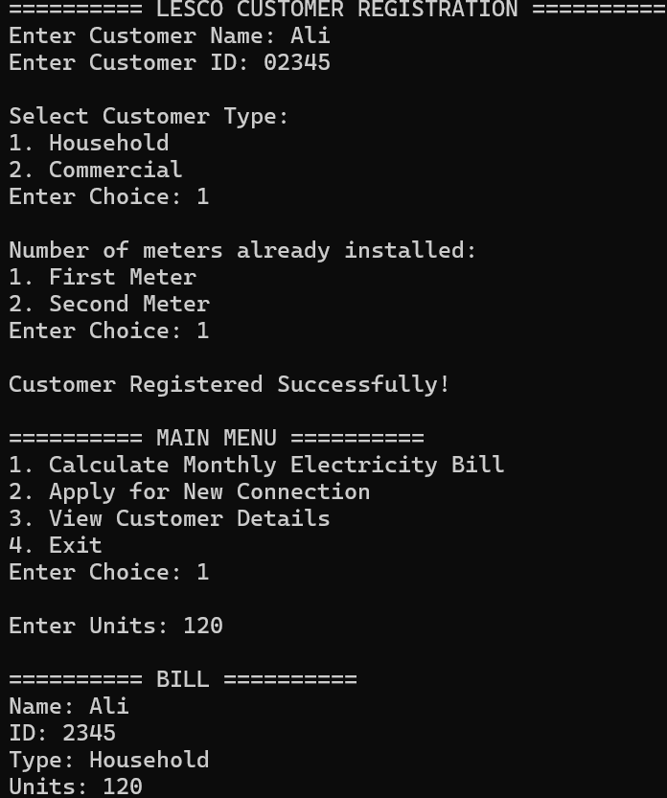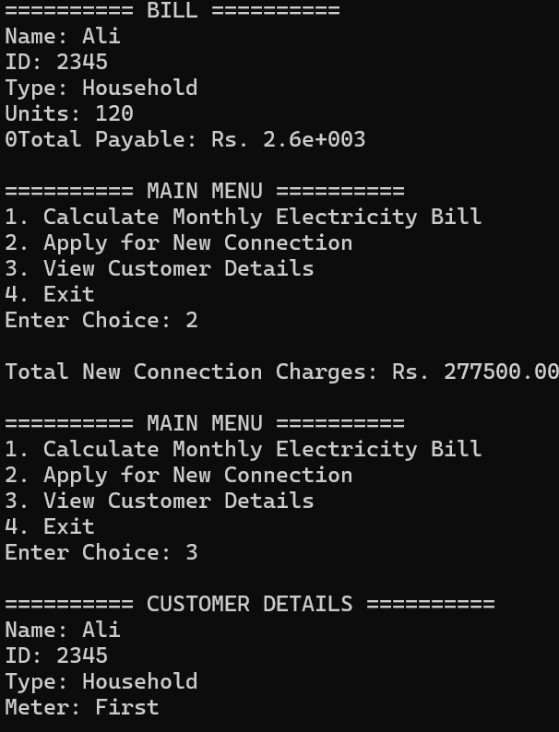
Program 2: Restaurant Billing Management System
#include <iostream>
#include <iomanip>
using namespace std;

// Menu data (1D arrays)
string items[] = {
"Chicken Burger", "Zinger Burger", "Pizza Small", "Pizza Large",
"Chicken Biryani", "BBQ Platter", "Fries", "Cold Drink"
};

int prices[] = {450, 550, 900, 1800, 350, 1200, 250, 120};
int quantity[8] = {0};

// Customer data
string name, contact, orderType;
int persons;

// Function declarations
void registerCustomer();
void displayMenu();
void placeOrder();
double calculateFoodBill();
double serviceCharges(double bill);
double gst(double bill);
double discount(double bill);
void displayCustomer();
void displayFinalBill();

int main() {
int choice;

registerCustomer();

do {
cout << "\n========== MAIN MENU ==========\n";
cout << "1. View Food Menu\n";
cout << "2. Place Order\n";
cout << "3. Calculate Bill\n";
cout << "4. View Customer Details\n";
cout << "5. Exit\n";
cout << "Enter choice: ";
cin >> choice;

switch(choice) {
case 1:
displayMenu();
break;

case 2:
placeOrder();
break;

case 3:
displayFinalBill();
break;

case 4:
displayCustomer();
break;

case 5:
cout << "Exiting program...\n";
break;

default:
cout << "Invalid choice!\n";
}

} while(choice != 5);

return 0;
}

// 1. Register customer
void registerCustomer() {
cout << "Enter Customer Name: ";
cin.ignore();
getline(cin, name);

cout << "Enter Contact Number: ";
cin >> contact;

cout << "Order Type (Dine-in/Takeaway): ";
cin >> orderType;

cout << "Number of Persons: ";
cin >> persons;
}

// 2. Display menu
void displayMenu() {
cout << "\n========== FOOD MENU ==========\n";
for(int i = 0; i < 8; i++) {
cout << i + 1 << ". " << items[i]
<< " - Rs. " << prices[i] << endl;
}
}

// 3. Place order
void placeOrder() {
int itemNo, qty;

displayMenu();

cout << "\nEnter item number (0 to stop): ";

while(true) {
cin >> itemNo;

if(itemNo == 0) break;

if(itemNo < 1 || itemNo > 8) {
cout << "Invalid item!\n";
continue;
}

cout << "Enter quantity: ";
cin >> qty;

quantity[itemNo - 1] += qty;

cout << "Add more items or 0 to stop: ";
}
}

// 4. Food bill
double calculateFoodBill() {
double total = 0;

for(int i = 0; i < 8; i++) {
total += quantity[i] * prices[i];
}

return total;
}

// 5. Service charges
double serviceCharges(double bill) {
if(orderType == "Dine-in" || orderType == "dine-in")
return bill * 0.10;
else
return bill * 0.05;
}

// 6. GST
double gst(double bill) {
return bill * 0.16;
}

// 7. Discount
double discount(double bill) {
if(bill >= 3000 && bill <= 5000)
return bill * 0.05;
else if(bill <= 10000)
return bill * 0.10;
else if(bill > 10000)
return bill * 0.15;
else
return 0;
}

// 8 & 9. Final bill + free delivery rule
void displayFinalBill() {
double foodBill = calculateFoodBill();
double service = serviceCharges(foodBill);
double tax = gst(foodBill);
double disc = discount(foodBill);

double total = foodBill + service + tax - disc;

cout << "\n========== RESTAURANT BILL ==========\n";
cout << "Customer Name: " << name << endl;
cout << "Order Type: " << orderType << endl;
cout << "Number of Persons: " << persons << endl;

cout << fixed << setprecision(2);

cout << "\nFood Bill: Rs. " << foodBill;
cout << "\nService Charges: Rs. " << service;
cout << "\nGST: Rs. " << tax;
cout << "\nDiscount: Rs. " << disc;

if(total > 5000)
cout << "\nFree Delivery: Applied";

cout << "\n------------------------------------";
cout << "\nTotal Payable Amount: Rs. " << total;
cout << "\nEnjoy Your Meal :)\n";
cout << "====================================\n";
}

// 10. Customer details
void displayCustomer() {
cout << "\n========== CUSTOMER DETAILS ==========\n";
cout << "Name: " << name << endl;
cout << "Contact: " << contact << endl;
cout << "Order Type: " << orderType << endl;
cout << "Persons: " << persons << endl;
}
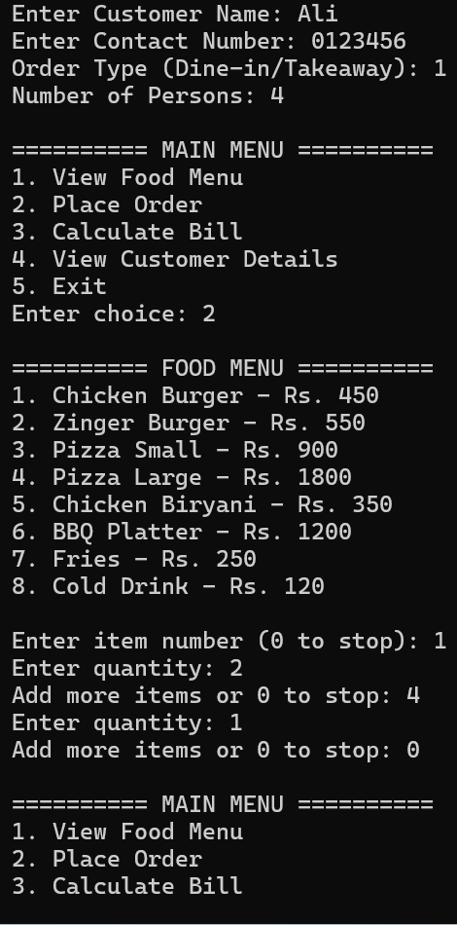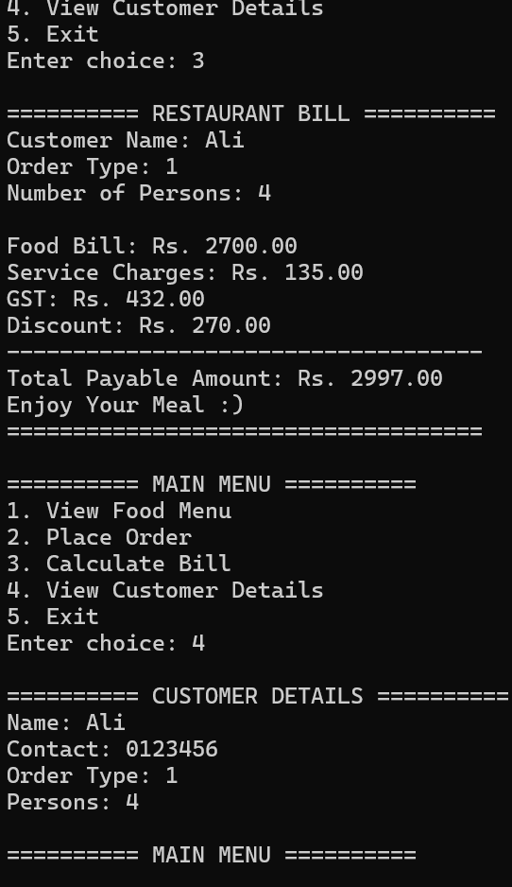
Program 3: Grocery Mart Billing System
#include <iostream>
#include <iomanip>
using namespace std;

// ---------- Grocery Data ----------

string items[] = {
"Rice 1 KG",
"Sugar 1 KG",
"Cooking Oil 1 Litre",
"Milk Pack",
"Tea Pack",
"Flour 5 KG",
"Eggs Dozen",
"Detergent"
};

double prices[] = {
350, 180, 580, 220,
450, 950, 320, 600
};

int quantity[8] = {0};

// ---------- Customer Data ----------

string customerName;
int customerID;
int customerType;
int paymentMethod;

// ---------- Function Declarations ----------

void registerCustomer();
void displayGroceryItems();
void addItemsToCart();

double calculateGrossBill();
double calculateSalesTax(double bill);
double calculateMembershipDiscount(double bill);
double calculateBillDiscount(double bill);
double calculateCardCharges(double bill);

int calculateLoyaltyPoints(double bill);

void displayCustomerDetails();
void displayFinalBill();

// ---------- Main Function ----------

int main()
{
int choice;

registerCustomer();

do
{
cout << "\n========== MAIN MENU ==========\n";
cout << "1. View Grocery Items\n";
cout << "2. Add Items to Cart\n";
cout << "3. Calculate Bill\n";
cout << "4. View Customer Details\n";
cout << "5. Exit\n";

cout << "Enter Choice: ";
cin >> choice;

switch(choice)
{
case 1:
displayGroceryItems();
break;

case 2:
addItemsToCart();
break;

case 3:
displayFinalBill();
break;

case 4:
displayCustomerDetails();
break;

case 5:
cout << "\nProgram Exited Successfully!\n";
break;

default:
cout << "\nInvalid Choice!\n";
}

} while(choice != 5);

return 0;
}

// ---------- 1. Register Customer ----------

void registerCustomer()
{
cout << "========== CUSTOMER REGISTRATION ==========\n";

cout << "Enter Customer Name: ";
cin.ignore();
getline(cin, customerName);

cout << "Enter Customer ID: ";
cin >> customerID;

cout << "\nCustomer Type\n";
cout << "1. Regular Customer\n";
cout << "2. Member Customer\n";
cout << "Enter Choice: ";
cin >> customerType;

cout << "\nPayment Method\n";
cout << "1. Cash\n";
cout << "2. Card\n";
cout << "Enter Choice: ";
cin >> paymentMethod;
}

// ---------- 2. Display Grocery List ----------

void displayGroceryItems()
{
cout << "\n========== GROCERY ITEMS ==========\n";

for(int i = 0; i < 8; i++)
{
cout << i + 1 << ". "
<< items[i]
<< " - Rs. "
<< prices[i]
<< endl;
}
}

// ---------- 3. Add Items To Cart ----------

void addItemsToCart()
{
int itemNo, qty;

displayGroceryItems();

cout << "\nEnter Item Number (0 to stop): ";

while(true)
{
cin >> itemNo;

if(itemNo == 0)
break;

if(itemNo < 1 || itemNo > 8)
{
cout << "Invalid Item Number!\n";
continue;
}

cout << "Enter Quantity: ";
cin >> qty;

quantity[itemNo - 1] += qty;

cout << "Add More Items or 0 to stop: ";
}
}

// ---------- 4. Calculate Gross Bill ----------

double calculateGrossBill()
{
double total = 0;

for(int i = 0; i < 8; i++)
{
total += quantity[i] * prices[i];
}

return total;
}

// ---------- 5. Calculate Sales Tax ----------

double calculateSalesTax(double bill)
{
double tax = 0;

for(int i = 0; i < 8; i++)
{
double itemTotal = quantity[i] * prices[i];

// Food Items 1–7
if(i >= 0 && i <= 6)
{
tax += itemTotal * 0.05;
}

// Non-food Item 8
else
{
tax += itemTotal * 0.10;
}
}

return tax;
}

// ---------- 6. Membership Discount ----------

double calculateMembershipDiscount(double bill)
{
if(customerType == 2)
{
return bill * 0.07;
}

return 0;
}

// ---------- 7. Bill Amount Discount ----------

double calculateBillDiscount(double bill)
{
if(bill >= 5000 && bill <= 10000)
{
return bill * 0.05;
}

else if(bill > 10000)
{
return bill * 0.10;
}

return 0;
}

// ---------- 8. Card Charges ----------

double calculateCardCharges(double bill)
{
if(paymentMethod == 2)
{
return bill * 0.02;
}

return 0;
}

// ---------- 9. Loyalty Points ----------

int calculateLoyaltyPoints(double bill)
{
return bill / 100;
}

// ---------- Final Bill ----------

void displayFinalBill()
{
double grossBill = calculateGrossBill();

double salesTax =
calculateSalesTax(grossBill);

double membershipDiscount =
calculateMembershipDiscount(grossBill);

double billDiscount =
calculateBillDiscount(grossBill);

double subtotal =
grossBill
+ salesTax
- membershipDiscount
- billDiscount;

double cardCharges =
calculateCardCharges(subtotal);

double totalBill =
subtotal + cardCharges;

// Loyalty Points

int generatedPoints =
calculateLoyaltyPoints(totalBill);

int existingPoints;

cout << "\nGenerated Loyalty Points: "
<< generatedPoints << endl;

cout << "Enter Your Existing Loyalty Points "
<< "(Enter 0 if new user): ";

cin >> existingPoints;

int totalPoints =
generatedPoints + existingPoints;

cout << "Loyalty Points after Purchase: "
<< totalPoints << endl;

int choice;

cout << "\nPress 1 to redeem loyalty points\n";
cout << "Press 2 to continue\n";
cout << "Enter Choice: ";
cin >> choice;

if(choice == 1)
{
totalBill -= totalPoints;

if(totalBill < 0)
{
totalBill = 0;
}
}

cout << fixed << setprecision(2);

cout << "\n========== GROCERY MART BILL ==========\n";

cout << "Customer Name: "
<< customerName << endl;

if(customerType == 1)
cout << "Customer Type: Regular Customer\n";
else
cout << "Customer Type: Member Customer\n";

if(paymentMethod == 1)
cout << "Payment Method: Cash\n";
else
cout << "Payment Method: Card\n";

cout << "\nGross Bill: Rs. "
<< grossBill;

cout << "\nSales Tax: Rs. "
<< salesTax;

cout << "\nMembership Discount: Rs. "
<< membershipDiscount;

cout << "\nBill Discount: Rs. "
<< billDiscount;

cout << "\nCard Charges: Rs. "
<< cardCharges;

cout << "\nGenerated Loyalty Points: "
<< generatedPoints;

cout << "\nLoyalty Points after Purchase: "
<< totalPoints;

cout << "\n---------------------------------------";

cout << "\nTotal Payable Amount: Rs. "
<< totalBill;

cout << "\nThank You For Shopping :)";

cout << "\n=======================================\n";
}

// ---------- Customer Details ----------

void displayCustomerDetails()
{
cout << "\n========== CUSTOMER DETAILS ==========\n";

cout << "Customer Name: "
<< customerName << endl;

cout << "Customer ID: "
<< customerID << endl;

if(customerType == 1)
cout << "Customer Type: Regular Customer\n";
else
cout << "Customer Type: Member Customer\n";

if(paymentMethod == 1)
cout << "Payment Method: Cash\n";
else
cout << "Payment Method: Card\n";
}
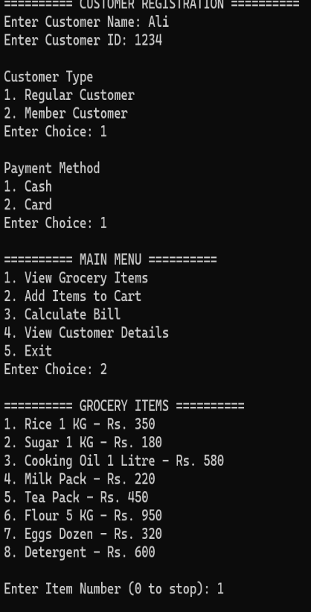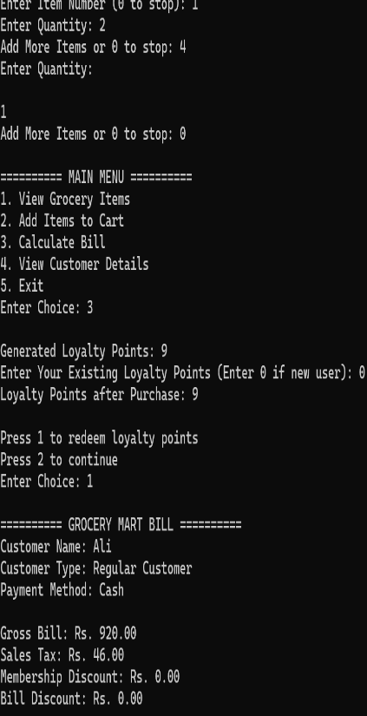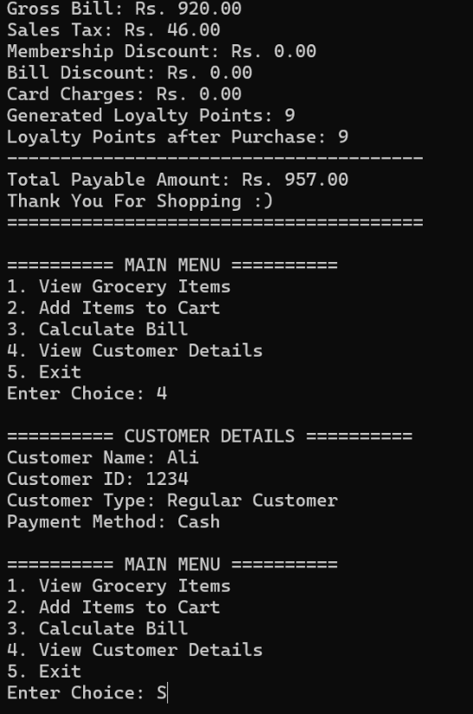
Program 4: Online Shopping System
#include <iostream>
#include <iomanip>
using namespace std;

// Global Variables
string userName, email, city;
int customerType; // 1 = New, 2 = Returning

string products[8] = {
"T-Shirt",
"Jeans",
"Shoes",
"Watch",
"Handbag",
"Headphones",
"Mobile Cover",
"Perfume"
};

int prices[8] = {
1200,
3500,
5000,
2500,
4200,
3000,
700,
2800
};

int cart[100];
int cartCount = 0;

// Function Prototypes
void registerUser();
void displayProducts();
void addToCart();
double calculateProductTotal();
double calculateGST(double total);
double calculateDeliveryCharges();
double calculateCustomerDiscount(double total);
double calculateOrderValueDiscount(double total);
double calculatePaymentCharges(double amount, int paymentMethod);
void displayCheckoutBill();
void viewUserDetails();

int main()
{
registerUser();

int choice;

do
{
cout << "\n========== ONLINE SHOPPING SYSTEM ==========\n";
cout << "1. View Products\n";
cout << "2. Add Product to Cart\n";
cout << "3. Calculate Checkout Bill\n";
cout << "4. View User Details\n";
cout << "5. Exit\n";
cout << "Enter Choice: ";
cin >> choice;

switch(choice)
{
case 1:
displayProducts();
break;

case 2:
addToCart();
break;

case 3:
displayCheckoutBill();
break;

case 4:
viewUserDetails();
break;

case 5:
cout << "\nThank You for Using Online Shopping System!\n";
break;

default:
cout << "\nInvalid Choice!\n";
}

} while(choice != 5);

return 0;
}

// Register User
void registerUser()
{

cout << "Enter User Name: ";
getline(cin, userName);

cout << "Enter Email: ";
getline(cin, email);

cout << "Enter City: ";
getline(cin, city);

cout << "\nCustomer Type\n";
cout << "1. New Customer\n";
cout << "2. Returning Customer\n";
cout << "Enter Choice: ";
cin >> customerType;
}

// Display Products
void displayProducts()
{
cout << "\n========== PRODUCT LIST ==========\n";

for(int i = 0; i < 8; i++)
{
cout << i + 1 << ". "
<< products[i]
<< " - Rs. "
<< prices[i]
<< endl;
}
}

// Add Product To Cart
void addToCart()
{
int productNo;

displayProducts();

cout << "\nEnter Product Number: ";
cin >> productNo;

if(productNo >= 1 && productNo <= 8)
{
cart[cartCount] = productNo - 1;
cartCount++;

cout << products[productNo - 1]
<< " added to cart successfully.\n";
}
else
{
cout << "Invalid Product Number!\n";
}
}

// Calculate Product Total
double calculateProductTotal()
{
double total = 0;

for(int i = 0; i < cartCount; i++)
{
total += prices[cart[i]];
}

return total;
}

// Calculate GST
double calculateGST(double total)
{
return total * 0.17;
}

// Calculate Delivery Charges
double calculateDeliveryCharges()
{
if(city == "Lahore" ||
city == "Karachi" ||
city == "Islamabad")
{
return 250;
}

return 500;
}

// Customer Discount
double calculateCustomerDiscount(double total)
{
if(customerType == 1)
{
return total * 0.05;
}
else if(customerType == 2)
{
return total * 0.10;
}

return 0;
}

// Order Value Discount
double calculateOrderValueDiscount(double total)
{
if(total >= 5000 && total <= 10000)
{
return total * 0.05;
}
else if(total > 10000)
{
return total * 0.12;
}

return 0;
}

// Payment Charges
double calculatePaymentCharges(double amount, int paymentMethod)
{
if(paymentMethod == 2)
{
return amount * 0.025;
}

return 0;
}

// View User Details
void viewUserDetails()
{
cout << "\n========== USER DETAILS ==========\n";

cout << "User Name: " << userName << endl;
cout << "Email: " << email << endl;
cout << "City: " << city << endl;

if(customerType == 1)
cout << "Customer Type: New Customer\n";
else
cout << "Customer Type: Returning Customer\n";
}

// Display Checkout Bill
void displayCheckoutBill()
{
if(cartCount == 0)
{
cout << "\nCart is Empty!\n";
return;
}

double productTotal = calculateProductTotal();
double gst = calculateGST(productTotal);
double deliveryCharges = calculateDeliveryCharges();
double customerDiscount =
calculateCustomerDiscount(productTotal);
double orderDiscount =
calculateOrderValueDiscount(productTotal);

int paymentMethod;

cout << "\nSelect Payment Method\n";
cout << "1. Cash on Delivery\n";
cout << "2. Debit/Credit Card\n";
cout << "Enter Choice: ";
cin >> paymentMethod;

double paymentCharges =
calculatePaymentCharges(productTotal, paymentMethod);

double finalAmount =
productTotal +
gst +
deliveryCharges +
paymentCharges -
customerDiscount -
orderDiscount;

cout << fixed << setprecision(2);

cout << "\n\n========== ONLINE SHOPPING BILL ==========\n";

cout << "User Name: " << userName << endl;
cout << "City: " << city << endl;

if(customerType == 1)
cout << "Customer Type: New Customer\n";
else
cout << "Customer Type: Returning Customer\n";

cout << "\nProduct Total: Rs. " << productTotal << endl;
cout << "GST: Rs. " << gst << endl;
cout << "Delivery Charges: Rs. "
<< deliveryCharges << endl;
cout << "Customer Discount: Rs. "
<< customerDiscount << endl;
cout << "Order Discount: Rs. "
<< orderDiscount << endl;
cout << "Payment Charges: Rs. "
<< paymentCharges << endl;

cout << "------------------------------------------\n";
cout << "Final Payable Amount: Rs. "
<< finalAmount << endl;

cout << "Thank You for Shopping :)\n";
cout << "==========================================\n";
}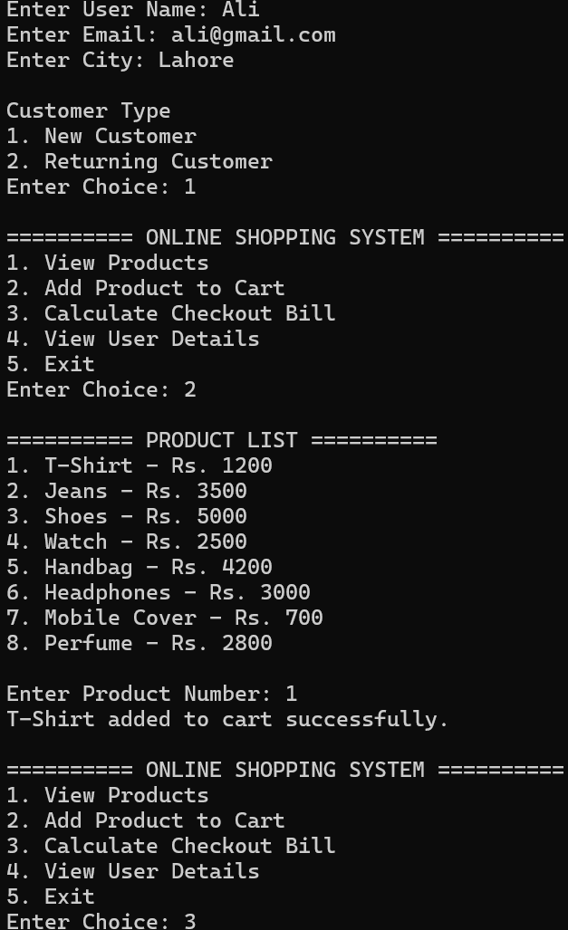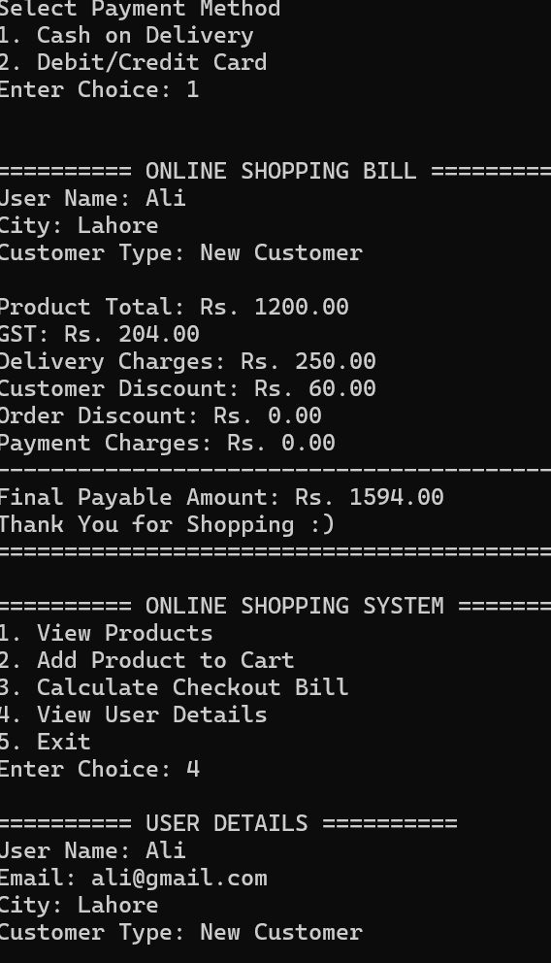

Program 5: Social Media Management System
#include <iostream>
#include <iomanip>
using namespace std;

// Platform Data (1D Arrays)
string platforms[] = {
"Instagram",
"Facebook",
"LinkedIn"
};

double platformCharges[] = {
15000,
12000,
20000
};

// Client Data
string clientName;
string businessName;
int businessType; // 1=Small, 2=Medium, 3=Corporate
int campaignDuration;

int selectedPlatform = -1;

int staticPosts = 0;
int reelPosts = 0;
int carouselPosts = 0;

double adBudget = 0;

// Function Prototypes
void registerClient();
void displayPlatforms();
void selectPlatform();
double calculatePostDesignCost();
double calculateAdHandlingFee();
double calculateExtraDurationCharges();
double calculateGST(double amount);
double calculateDiscount(double amount);
void displayFinalCampaignBill();
void displayClientDetails();

int main()
{
int choice;

registerClient();

do
{
cout << "\n========== SOCIAL MEDIA MANAGEMENT SYSTEM ==========\n";
cout << "1. View Platforms\n";
cout << "2. Select Campaign Platform\n";
cout << "3. Calculate Campaign Cost\n";
cout << "4. View Client Details\n";
cout << "5. Exit\n";
cout << "Enter Choice: ";
cin >> choice;

switch(choice)
{
case 1:
displayPlatforms();
break;

case 2:
selectPlatform();
break;

case 3:
displayFinalCampaignBill();
break;

case 4:
displayClientDetails();
break;

case 5:
cout << "\nProgram Closed Successfully.\n";
break;

default:
cout << "\nInvalid Choice!\n";
}

} while(choice != 5);

return 0;
}

// 1. Register Client
void registerClient()
{
cin.ignore();

cout << "Enter Client Name: ";
getline(cin, clientName);

cout << "Enter Business Name: ";
getline(cin, businessName);

cout << "\nBusiness Type\n";
cout << "1. Small Business\n";
cout << "2. Medium Business\n";
cout << "3. Corporate Business\n";
cout << "Enter Choice: ";
cin >> businessType;

cout << "Enter Campaign Duration (Days): ";
cin >> campaignDuration;
}

// 2. Display Platforms
void displayPlatforms()
{
cout << "\n========== SOCIAL MEDIA PLATFORMS ==========\n";

for(int i = 0; i < 3; i++)
{
cout << i + 1 << ". "
<< platforms[i]
<< " - Rs. "
<< platformCharges[i]
<< endl;
}
}

// 3. Select Platform
void selectPlatform()
{
displayPlatforms();

cout << "\nSelect Platform Number: ";
cin >> selectedPlatform;

if(selectedPlatform < 1 || selectedPlatform > 3)
{
cout << "Invalid Platform Selection!\n";
selectedPlatform = -1;
}
else
{
cout << platforms[selectedPlatform - 1]
<< " Selected Successfully.\n";
}
}

// 4. Calculate Post Design Cost
double calculatePostDesignCost()
{
cout << "\nEnter Number of Static Posts: ";
cin >> staticPosts;

cout << "Enter Number of Reel/Video Posts: ";
cin >> reelPosts;

cout << "Enter Number of Carousel Posts: ";
cin >> carouselPosts;

double cost =
(staticPosts * 1000) +
(reelPosts * 2500) +
(carouselPosts * 1800);

return cost;
}

// 5. Calculate Ad Handling Fee
double calculateAdHandlingFee()
{
cout << "\nEnter Advertisement Budget: ";
cin >> adBudget;

if(adBudget < 50000)
return adBudget * 0.05;

else if(adBudget <= 100000)
return adBudget * 0.08;

else
return adBudget * 0.10;
}

// 6. Calculate Extra Duration Charges
double calculateExtraDurationCharges()
{
if(campaignDuration > 30)
{
return (campaignDuration - 30) * 500;
}

return 0;
}

// 7. Calculate GST
double calculateGST(double amount)
{
return amount * 0.16;
}

// 8. Calculate Discount
double calculateDiscount(double amount)
{
if(businessType == 1)
return amount * 0.05;

else if(businessType == 2)
return amount * 0.08;

else if(businessType == 3)
return amount * 0.10;

return 0;
}

// 9. Display Final Campaign Bill
void displayFinalCampaignBill()
{
if(selectedPlatform == -1)
{
cout << "\nPlease Select a Platform First!\n";
return;
}

double managementCharges =
platformCharges[selectedPlatform - 1];

double postDesignCost =
calculatePostDesignCost();

double handlingFee =
calculateAdHandlingFee();

double extraCharges =
calculateExtraDurationCharges();

double serviceCost =
managementCharges +
postDesignCost +
adBudget +
handlingFee +
extraCharges;

double gst =
calculateGST(serviceCost);

double discount =
calculateDiscount(serviceCost);

double finalCost =
serviceCost +
gst -
discount;

cout << fixed << setprecision(2);

cout << "\n\n========== SOCIAL MEDIA CAMPAIGN BILL ==========\n";

cout << "Client Name: "
<< clientName << endl;

cout << "Business Name: "
<< businessName << endl;

if(businessType == 1)
cout << "Business Type: Small Business\n";
else if(businessType == 2)
cout << "Business Type: Medium Business\n";
else
cout << "Business Type: Corporate Business\n";

cout << "Selected Platform: "
<< platforms[selectedPlatform - 1] << endl;

cout << "Campaign Duration: "
<< campaignDuration
<< " Days\n";

cout << "\nPlatform Management Charges: Rs. "
<< managementCharges << endl;

cout << "Post Design Cost: Rs. "
<< postDesignCost << endl;

cout << "Ad Budget: Rs. "
<< adBudget << endl;

cout << "Ad Handling Fee: Rs. "
<< handlingFee << endl;

cout << "Extra Duration Charges: Rs. "
<< extraCharges << endl;

cout << "GST: Rs. "
<< gst << endl;

cout << "Discount: Rs. "
<< discount << endl;

cout << "------------------------------------------------\n";

cout << "Final Campaign Cost: Rs. "
<< finalCost << endl;

cout << "================================================\n";
}

// 10. Display Client Details
void displayClientDetails()
{
cout << "\n========== CLIENT DETAILS ==========\n";

cout << "Client Name: "
<< clientName << endl;

cout << "Business Name: "
<< businessName << endl;

cout << "Campaign Duration: "
<< campaignDuration
<< " Days" << endl;

if(businessType == 1)
cout << "Business Type: Small Business\n";
else if(businessType == 2)
cout << "Business Type: Medium Business\n";
else
cout << "Business Type: Corporate Business\n";
}
